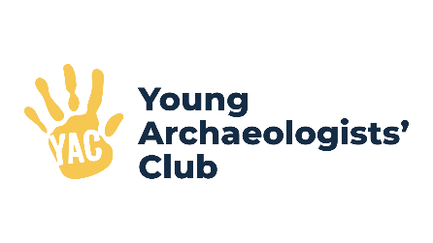
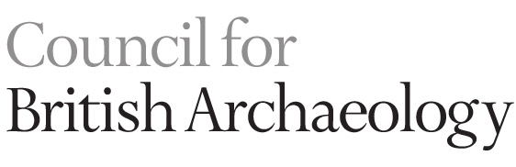
Sponsorship and
Gift Aid declaration form

Please sponsor me: ____________________________________________________________________

To (event): __________________________________________________________________________

In aid of: Young Archaeologists’ Club, who are part of the Council for British Archaeology (CBA)

We, who have given out names and addresses below and have ticked the box headed ‘Gift Aid?’, want the charity named above to reclaim tax on the donation detailed below, given on the date shown. We understand that each of us must pay an amount of income tax or capital gains tax at least equal to the tax reclaimed by the CBA on the donation.

Full name  (First name and surname) | Home address  (Not your work address (this is essential for Gift Aid)) | Postcode | Amount (£) | Date paid | Gift Aid?  Please tick ()
Total donations received |  |  | £
Total Gift Aid donation |  |  | £

