Branch closure form  Thank you for the time and energy that you have put into your YAC Branch – we are always sorry to see a Branch close. To help us keep our records up to date, and to make the experience of YAC volunteers and members better in future, please complete the form below. |  |  |  |  |  |  |  |  | 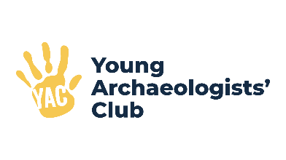
Branch details
Name of Branch:
Name(s) of Branch Leader(s) and Assistant(s):

How many members currently attend your sessions?
Have these members been told that your Branch is closing? |  |  |  |  |  |  |  | Yes [ ] No [ ]
Branch finances
Branch bank account name:
Sort Code:
Account number:
Account balance: |  | £
Please give the names, addresses, and contact details for the current account signatories:

Please describe how members supported the Branch financially (e.g. did they pay a fee for each session?)

Closure process
Please outline why your Branch is closing:

When you return this form to YAC HQ, please also return the following documents.
Please also make sure that any other paperwork or electronic files containing personal details about your Branch members are securely destroyed. If you have paperwork to shred and do not have the facilities, then you are welcome to send this to YAC HQ for shredding.

Please return the following: tick if they are enclosed:

[ ] Copy of information sent to Branch members regarding Branch closure
[ ] Branch register(s)
[ ] Branch bank account book, mandate or other documentation
[ ] Cheque for the account balance, made payable to the Council for British Archaeology
[ ] Any Incident, Accident, or Safeguarding Referral forms for the last 3 years
[ ] Risk Assessments for your Branch sessions for the last 3 years

If you have any resources which were purchased with Branch money, please speak to YAC HQ about donating these to another Branch in your region.
Is there anything else you would like to tell us about the closure of your Branch?

Form completed by:
Signature: |  |  |  |  | Date:
Please return this form along with the paperwork outlined above to: Rachel Arbury – yac@yac-uk.org or YAC, De Grey House, St Leonards’ Place, York, YO1 7HE
If you have any questions about completing this form, or the Branch closure process, please contact YAC HQ on 01904 521244.

