After-school Young Archaeologists’ Club Branch application form  This form is for established education providers with their own child protection, health and safety, and insurance provision, who would like to affiliate their own young person’s archaeology club to YAC. | 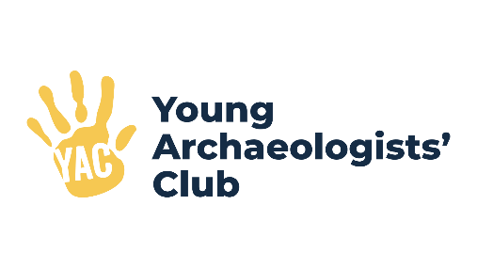
Proposed Branch name:
Proposed start date (please allow at least two months):

What contact information should we list on the YAC website?
Contact name:
Contact telephone number:
Contact email address:
Website (if applicable):

What is the address of your school?

If different, what address should YAC HQ use when sending you post?

YAC sends regular electronic newsletters to each Branch and has a Branch email network for discussion and sharing information. Please list any email addresses you would like to add to these:

Who will be in your Branch team? (Please include names and job roles within your school):

Please provide details of your school’s child protection, health and safety, and insurance provision:

Please tell us why you would like to affiliate your group to the Young Archaeologists’ Club:

Which school years will your branch be available to?

YAC Branches typically meet once a month however you may prefer to run weekly or fortnightly sessions. Whichever you choose, please provide an outline of your session plans for the first six sessions. Please also attach an example risk assessment for one of the sessions:

Do you plan to charge your Branch members, either on an annual or per session basis? There is no requirement to do so but may be something you wish to consider to help cover the costs of resources and activities.

Are there any areas in particular where you feel you need support from the Young Archaeologists’ Club?

Declaration
No
Yes

- We confirm we have a written Health and Safety Policy.

- We confirm we have Public Liability Insurance which

covers the activities undertaken during a YAC session.

- We confirm all named leaders have current Enhanced

Disclosure and Barring checks.

- We confirm there will be a qualified first aider available

during sessions.

- We have a current venue risk assessment that all leaders

are familiar with.

As part of the application process we will also request a copy of your child protection/safeguarding policy and an example session risk assessment.

Please return this form to us by email or post using the details below. We will be in touch to arrange a meeting to discuss your plans. Thank you for your interest in YAC.
yac@yac-uk.org
YAC Branch Applications
The Council for British Archaeology
De Grey House
St Leonards Way
York
YO1 7HE

