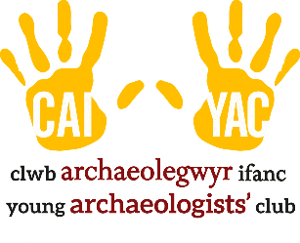
YOUNG ARCHAEOLOGISTS’ CLUB IMPORTANT CONTACT DETAILS
Branch name:
Main Leader(s):
Branch Contact Details:
Address:

Telephone:
Email:

YAC HQ Contact Details:
Address: | De Grey House, St Leonard’s Place, York, YO1 7HE
Telephone: | 01904 671417
Email: | yac@yac-uk.org

YAC Designated Safeguarding Lead:
Name | Joanne Kirton,  Delivery and Engagement Manager for the Council for British Archaeology
Telephone: | 0773859174
Email: | joannekirton@archaeologyuk.org  Use CHILD PROTECTION as the subject heading of an email and mark as RESTRICTED.

Local Safeguarding Board / Children’s Services Contact Details:
Address:

Telephone:
Email:

Local Police Contact Details:
Address:

Telephone: | 101 /
Email:

Use the space below to provide specific contact details that your branch requires (e.g. venue provider, local GP, etc).
Contact Details for:
Address:

Telephone:
Email:

Contact Details for:
Address:

Telephone:
Email:

Contact Details for:
Address:

Telephone:
Email:

Contact Details for:
Address:

Telephone:
Email:

Contact Details for:
Address:

Telephone:
Email:

Contact Details for:
Address:

Telephone:
Email:

