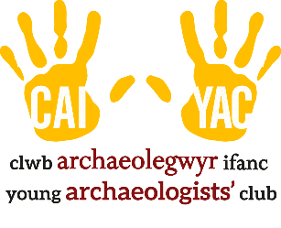
YOUNG ARCHAEOLOGISTS’ CLUB MEDICATION LOG

Branch Name:
YAC Leader:

Medication being held during the YAC session by the leaders:
Please complete whenever a medication (prescription and non-prescription) is provided for a session.
When the medication is collected at the end of a session, the volunteer or parent/carer should sign to show that they have received the items.
Date | Name of member/volunteer | Name of medication | Amount supplied | Individual Support Plan held & up to date* | Signature upon collection
/ / |  |  |  | Yes ☐ No ☐
/ / |  |  |  | Yes ☐ No ☐
/ / |  |  |  | Yes ☐ No ☐
/ / |  |  |  | Yes ☐ No ☐
/ / |  |  |  | Yes ☐ No ☐
/ / |  |  |  | Yes ☐ No ☐
*If no, please ensure that this is completed prior to medication being held and/or administered.

Medication administered during the YAC session:
Medication will only be administered as described in the member or volunteer’s Individual Support Plan. Medication will be administered by those trained to do so.
Date | Time | Name of member/volunteer | Name of medication | Dose given | Any reactions? | Signature of YAC leader/ volunteer | Print name
/ / | :
/ / | :
/ / | :
/ / | :
/ / | :

