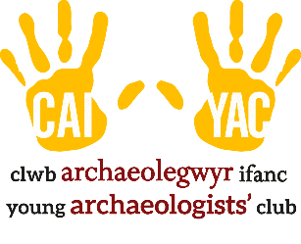
Young Archaeologists’ Club
Sunscreen Permission Form

Name of child:
Name of YAC branch:

As the parent/carer of child named above, I understand that my child will be taking part in outdoor activities. Therefore, I give my permission for YAC leaders and volunteers at the above-named YAC branch to apply a sunscreen product (of SPF-15 or above) as specified below when they will be outside.

I understand that sunscreen may be applied to exposed skin, including but not limited to the face, tops of the ears, nose and bare shoulders, arms and legs. | ☐
I understand that if sunscreen is provided it will be the following brand/type:

I have checked all applicable information regarding the type and use of sunscreen to be used. | ☐
I do not know of any allergies that my child has to sunscreen. | ☐
I have provided the following brand/type of sunscreen for use on my child: | ☐
My child is allergic to some sunscreens, please only use the following brand(s)/type(s) of sunscreen: | ☐
For medical or other reasons, please do not apply sunscreen to my child. | ☐
For medical or other reasons, please do not apply sunscreen to the following areas of my child’s body: | ☐

Parent/Carer full name (please print):
Parent/Carer signature: Date:

