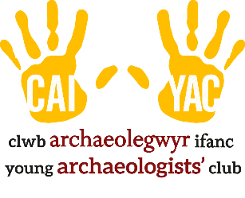

YOUNG ARCHAEOLOGISTS’ CLUB – SAFEGUARDING INCIDENT REPORT FORM

This form should be used to record any safeguarding incident. Be careful to record the events as they occurred and try not to include personal opinions.

Branch Name:
YAC Leader:

Where did the incident take place?
When did the incident take place? (Date and time)
Summarise the incident factually:
Who witnessed or is aware of the incident?
What steps were taken and by whom?
Was anyone spoken with (e.g. parent/carer, emergency services, venue operator)?
Record who was spoken to, when, and by whom.
Are any further steps to be taken?

Details of the person completing this form
Name of the person completing this form:
Contact details:
Signature: |  |  | Date:
Please ask another Leader or Assistant at your branch to review this form and countersign here to confirm that they agree with your account of the incident.
Name:
Contact details:
Signature: |  |  | Date:

