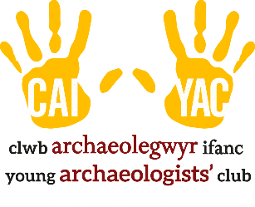
YOUNG ARCHAEOLOGISTS’ CLUB

INDUCTION CHECKLIST

Use this checklist to ensure your YAC leader or volunteer has the relevant information required to support the planning and delivery of activities as part of your Young Archaeologists’ Club sessions.
Sections A and B should be undertaken at the start of volunteering with YAC. Section C can be undertaken within the first year of volunteering.

- Basic induction | Yes | Signed | Date
My role in planning and delivering sessions safely has been explained | ☐
I know where to find my branch’s Health & Safety Folder | ☐
I know what information is held in my branch’s Health & Safety Folder | ☐
I have been shown around my regular venue and know where the facilities and emergency exits are | ☐
I understand what types of records that the branch has and their importance | ☐
How YAC branches and their volunteers protect personal information has been explained and I understand my role in this | ☐
The session planning and risk-benefit assessment has been explained and I know:  - What risk-benefit assessments should contain  - What my role as an assessor in risk management is  - That activities are reviewed regularly | ☐
Emergency procedures have been explained and I know:  - Where the emergency exits are  - Where the evacuation point is  - My role in an emergency  - Who to contact in an emergency  - Where I can find information and support | ☐
First aid procedures have been explained and I know:  - Who the first aiders are  - Where the First Aid box is  - What to do in a first aid emergency | ☐
The lost child procedure has been explained and I know what to do in this situation | ☐
The arrival, collection and late collection procedure has been explained and I know:  - The importance of session registers  - What to do in the case of a late or no collection | ☐
- Safeguarding | Yes | Signed | Date
I understand how to recognise a concern about safeguarding or wellbeing | ☐
I understand how to respond to a concern about safeguarding or wellbeing | ☐
I have been provided with an overview of the current safeguarding policies | ☐
I understand and agree to the Code of Behaviour | ☐
- Additional H&S induction topics | Yes | Signed | Date
Individual support plans | ☐
Food Safety | ☐
Fire Safety | ☐
Manual Handling | ☐
Use of chemicals and exposure to hazardous materials | ☐
Venue assessments | ☐
Behavioural management | ☐

