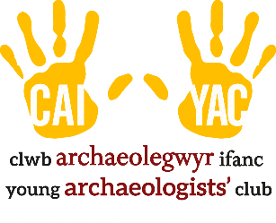

YOUNG ARCHAEOLOGISTS’ CLUB - INCIDENT REPORT FORM

This form should be used to record any incident other than first aid, behaviour or a safeguarding disclosure. Be careful to record the events as they occurred and try not to include personal opinions.

Branch Name:
YAC Leader:

Where did the incident take place?
When did the incident take place? (Date and time)
Summarise the incident factually:
Who witnessed the incident?
What steps were taken and by whom?
Was anyone spoken with (e.g. parent/carer, emergency services, venue operator)?
Record who was spoken to, when, and by whom.
Were photographs taken of the damaged equipment/property? Yes ☐ No ☐ N/A ☐
Are any further steps to be taken?

Details of the person completing this form
Name of the person completing this form:
Contact details:
Signature: |  |  | Date:
Please ask another Leader or Assistant at your branch to review this form and countersign here to confirm that they agree with your account of the incident.
Name:
Contact details:
Signature: |  |  | Date:

