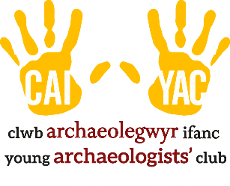
YOUNG ARCHAEOLOGISTS’ CLUB

FIRST AID PROCEDURES

Every branch should have a minimum of two registered first aiders, with at least one present at each branch meeting. Without this, your session is not covered by YAC insurance.
Every branch should have at least one First Aid Kit at every meeting.

Procedure for minor accidents

- A qualified first aider should deal with the accident with the assistance of another leader or assistant leader.
- The rest of the group must not be left unsupervised.
- Always explain clearly to a young person where you need to place your hands and check that they understand this.
- In cases of bumps to the head, monitor the person carefully for the rest of the session. If there is any sign of swelling or bruising, you should call their parents/carers to collect them. If there is any sign of concussion, you should call 999 for an ambulance. If you are unsure, call 111 for advice.
- Inform parents what has happened and the treatment provided.
- If in doubt, call 999 for an ambulance.
- Remember to complete an Accident Form and store it securely with the branch records.

Procedure for more serious accidents

- A qualified first aider should deal with the accident with the assistance of another leader or assistant leader.
- Ensure that the rest of the group is safe, supervised and kept calm.
- Call for an ambulance and give precise details of your location.
- Check the area is safe, give first aid as required and stay with the member until the ambulance arrives.
- Contact the member’s parents/carers and give a clear, simple, and factual account of the accident, what is happening and what you need them to do.
- Hand the member’s medical information to the ambulance crew.
- If the member wishes, a branch volunteer should travel in the ambulance with them (remember to sort out return travel arrangements). This should not be the first aider, who should remain with the group in case of any further incidents requiring first aid, such as delayed shock.
- Once the member is being cared for by others, complete an Accident Form.
- Any accident that involves attendance at hospital should be reported to YAC HQ. Call 01904 671 417 during office hours. Outside office hours, call Jo Kirton (Delivery and Engagement Manager) on 07738591744. We will ask you to send us a copy of your Accident Form.
- Under no circumstances should anyone at your branch speak to the press about an accident. If the press contacts you, please direct them to YAC HQ.

