
YOUNG ARCHAEOLOGISTS’ CLUB
EMERGENCY EVACUATION PROCEDURE

Amend as per your venue and branch requirements (delete this sentence when the document is updated).
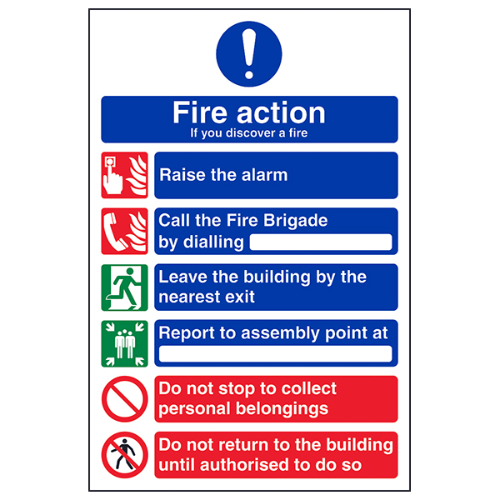
In the event of a fire or any other emergency situation requiring the evacuation of people from a YAC branch session:
999
__________________
- Move people away from the affected area.
- Activate the fire alarm via a break glass point or at the main panel.
- Assist people in leaving the building and proceeding to the assembly point. Be aware of stepped exits & routes easier for those with mobility issues.
- Report to ______________________ (e.g. YAC Leader / Venue Provider).
- __________________ will call 999, or direct someone else to do so.
- Only use firefighting equipment if you are trained and it is safe to do so. Do not put yourself or others in danger.
- __________________ is the designated person in charge during any incident, their instructions must be followed.
- Do not leave the site or re-enter the buildings until you are told to do so by __________________.
- Undertake a register check and report any missing members, volunteers or visitors to __________________.
- Please do support __________________ in managing the situation and ensure that any affected people are kept calm and looked after.

Please follow guidance provided by your venue operators.

