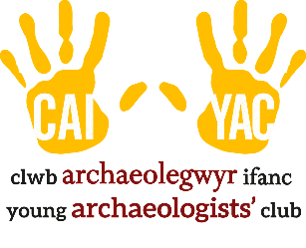
Young Archaeologists’ Club

Activity Instructions – for leaders

