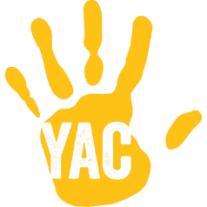
ACCIDENT FORM
This form should be completed for any accident or medical incident where First Aid is given. It should be completed by the person who administered First Aid.

In case of major accidents please also contact the YAC HQ team (Delivery and Engagement Manager, Jo Kirton on 07738591744) and send a copy of this form to yac@yac-uk.org. Do not speak to the media.
Branch name:
Injured person’s details
Name of injured person:
Age (if under 18):
Contact details:

Is the injured person a:
[ ] Branch member
[ ] Volunteer
[ ] Other (please specify)
Incident details
Where did the incident take place?

When did the incident take place?
(date and time)
Who dealt with the incident?

What was the nature of the injury or medical need?
How did the incident happen? (e.g. What activity was taking place? What was the injured person doing?
What happened after the incident? (e.g. did the injured person carry on with the activity? Did they go to hospital?)
Give the name(s) of the First Aider(s) who attended and describe what First Aid was administered:
Please give the names of and contact details for other witnesses to the incident:
Please record details of the family/next of kin informed: who was informed, how they were informed, by whom, and what arrangements were made.
Details of the person completing this form
Name of the person
completing this form:
Contact details:

Signature: |  |  |  | Date:
Please ask another Leader or Assistant at your Branch to review this form and countersign here to confirm that they agree with your account of the incident.
Name:
Contact details:

Signature: |  |  |  | Date:

